So the matrix A is non-invertible.

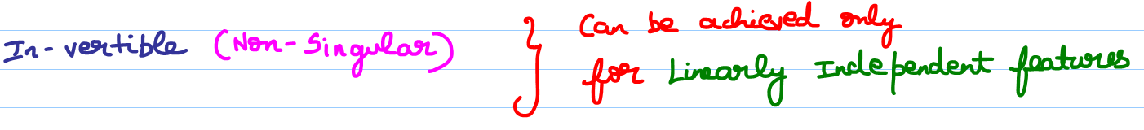

The above is one way of finding whether A is invertible or not. [ Too long and tedious for large matrices]

But yet there are many methods to find.

